CHAPTER 4: Chemical patterns

Worksheet 4.4

The structure of
the atom
Answers

The atom
1. The following drawing shows a simplified structure of an atom.

A  B  E | 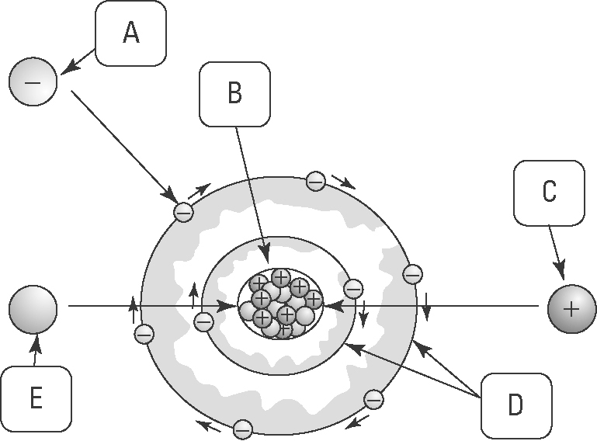 | Identify the labelled components of the atom.  Electron  A:  Nucleus  B:  Proton  C:  Electron shells  D:  Neutron  E:

The oxygen atom
2. The diagram below shows the atomic structure of oxygen.

 | 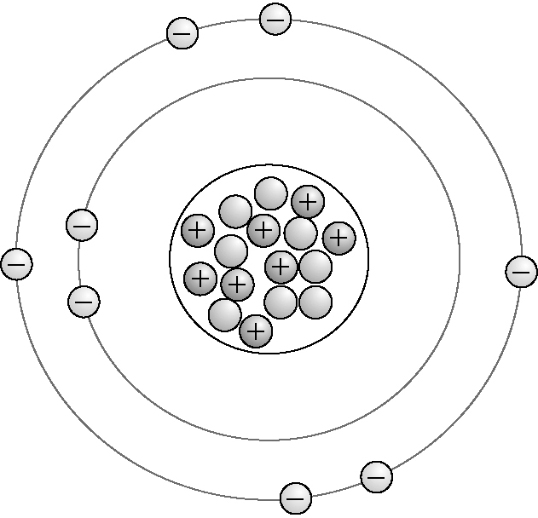 | (a) How many of each type of sub-atomic particle are present?  8  Electrons: ..................................  8  Protons: .....................................  8  Neutrons: ...................................

(b) Is the oxygen atom shown above neutral or charged? Explain.
Neutral — there is an equal number of protons and electrons.

16
(c) How many nucleons (total particles) are present in the nucleus?

CHAPTER 4: Chemical patterns

Worksheet 4.4

Page 2

Atoms and ions
3. The diagram below shows a nitrogen atom. A nitrogen atom can form an ion by gaining three more electrons, so that its electron configuration becomes 2, 8.

(a) In the diagram above, how many of each type of sub-atomic particle are present?
7
Electrons: ..................................
7
Protons: .....................................
7
Neutrons: ...................................

(b) Draw the nitrogen ion described above.
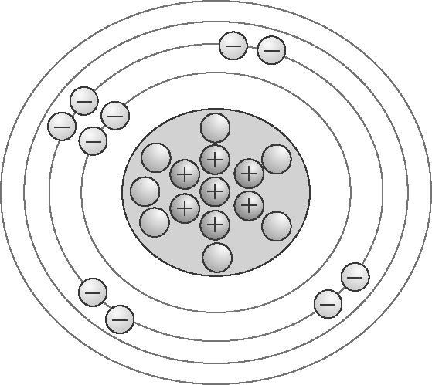

(c) In the diagram you have just drawn, how many of each type of sub-atomic particle are present?
10
Electrons: ..................................
7
Protons: .....................................
7
Neutrons: ...................................

